Animation

Class vii

Lab 22

**Lab Objectives:**

* Making a very simple animation

In previous lab you have learned poster making using MS PowerPoint software. Today you will learn how to create animation using PowerPoint.

In your project you will move a paper plane from one place to another. So let’s start.

Open MS PowerPoint as before and delete default text box.

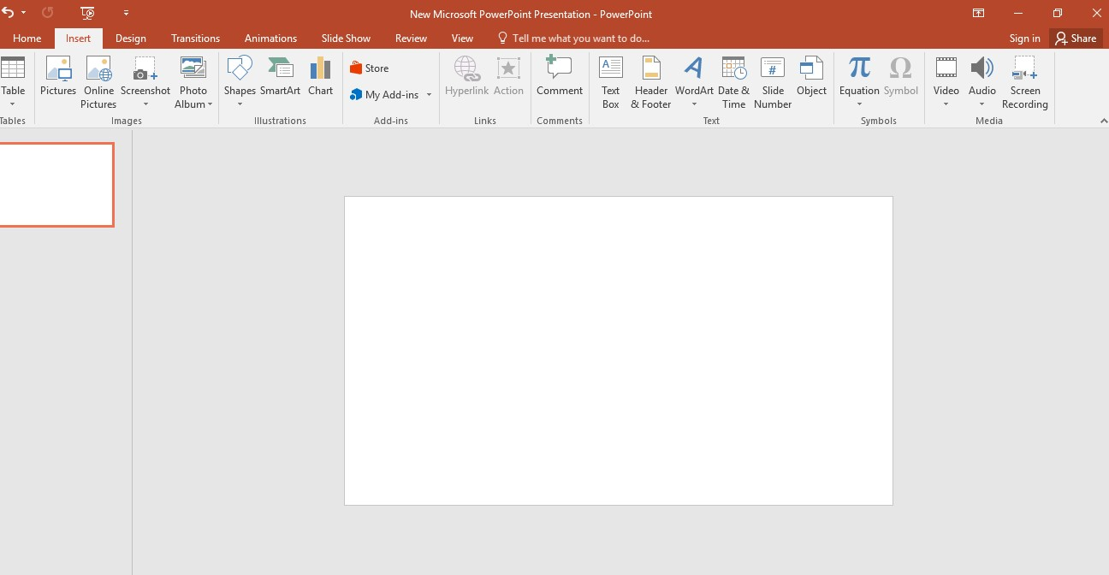

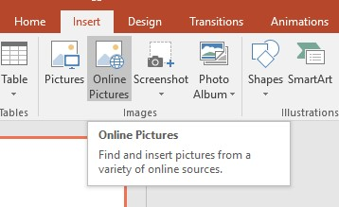Click insert from the menu bar then click Online Pictures. Make sure your internet connection is Ok.

You will see a search box. Write river cartoon and press enter.

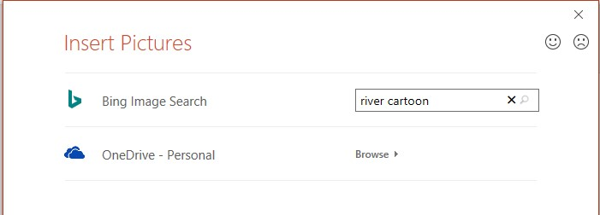We are going to select a picture for our animation background.

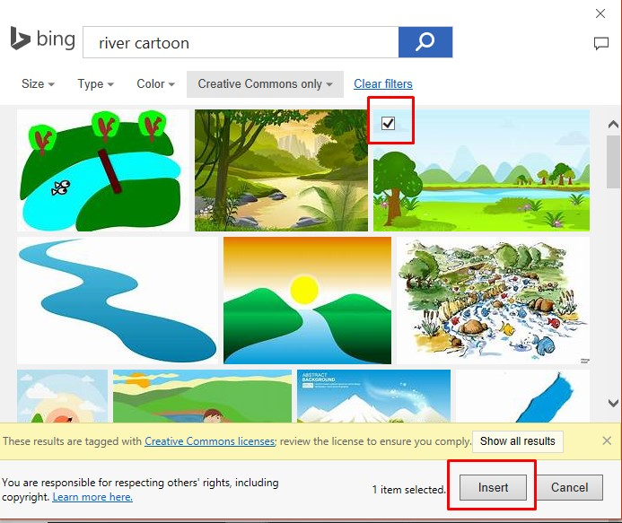You’ll see lots of picture there. Click one of them and click on insert.

Resize picture according to your slide size.

Now it is fit with slide size.



Search paper plane png from online



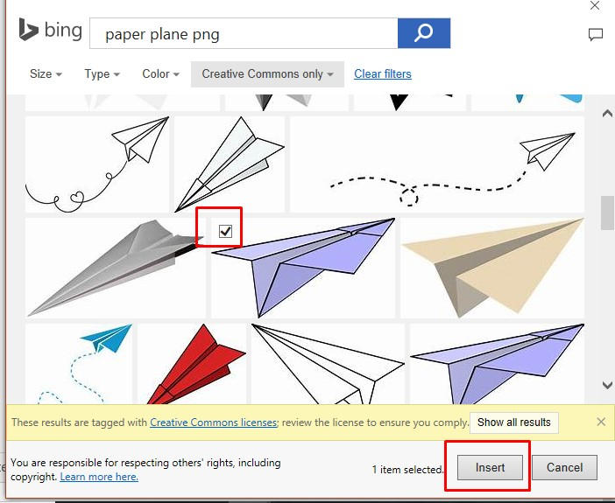Choose one of them and insert

Resize the plane. After that minimize your slide size and put the plane outside of your slide.

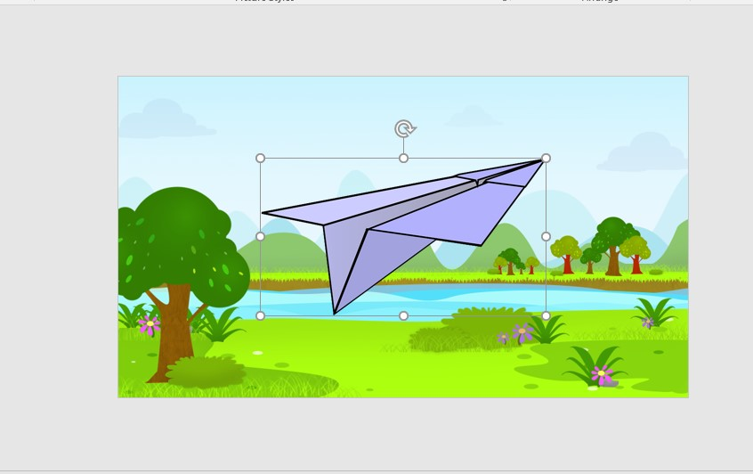

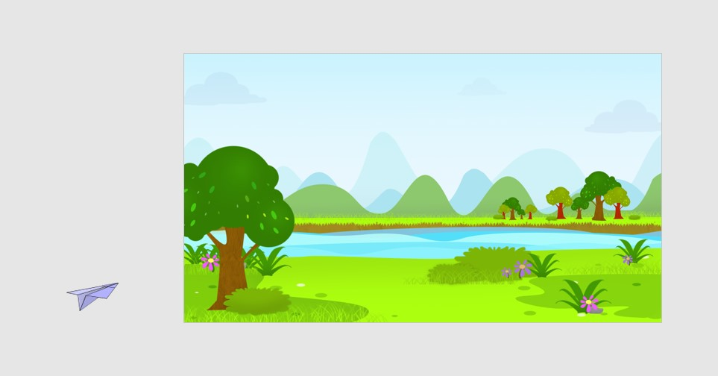

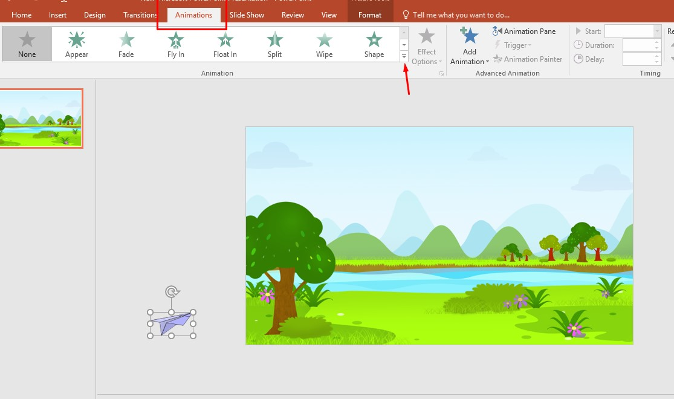now click your plane then click on Animation from the menu bar and click bottom down button which is beside the Effect Options.

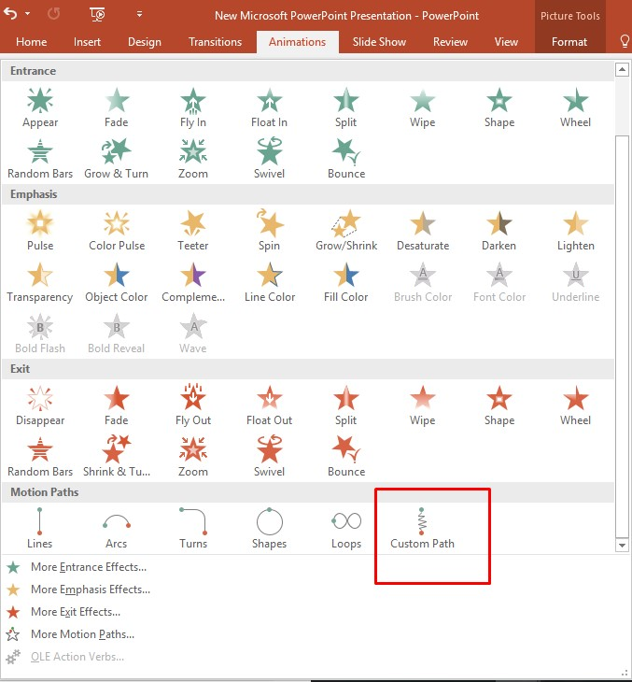Click on Custom path.

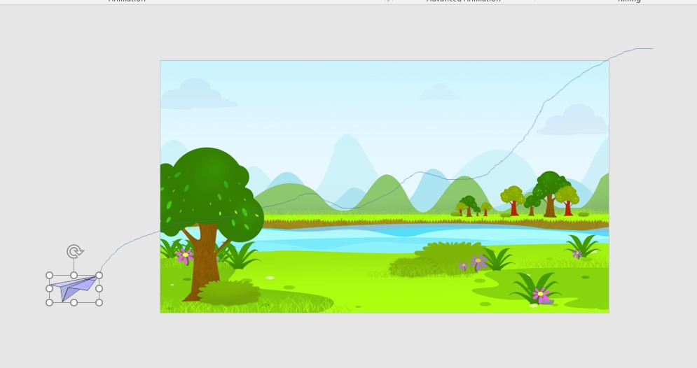draw a line from your plane. This line is the path. Your plane will follow this path during movement.

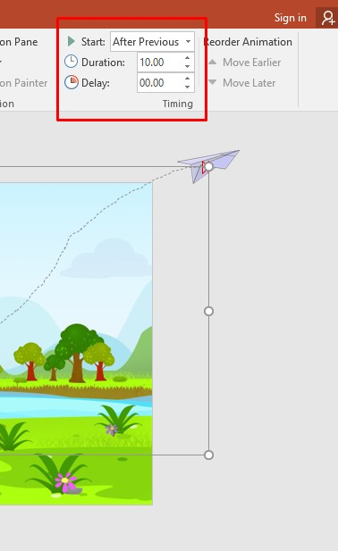from the animation menu bar change the setting of this area exactly the picture is showing below

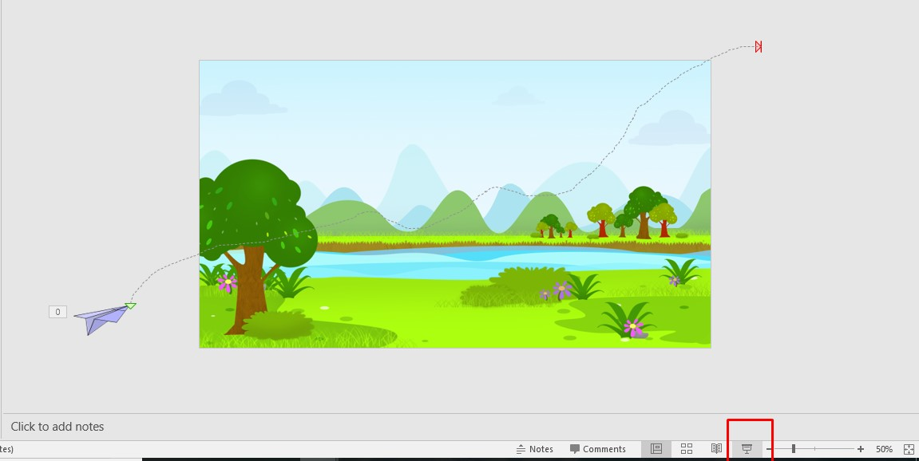you can see your animation by clicking slideshow button

Now it’s time to export the video.

Go to file and click on export

Click on Create a video

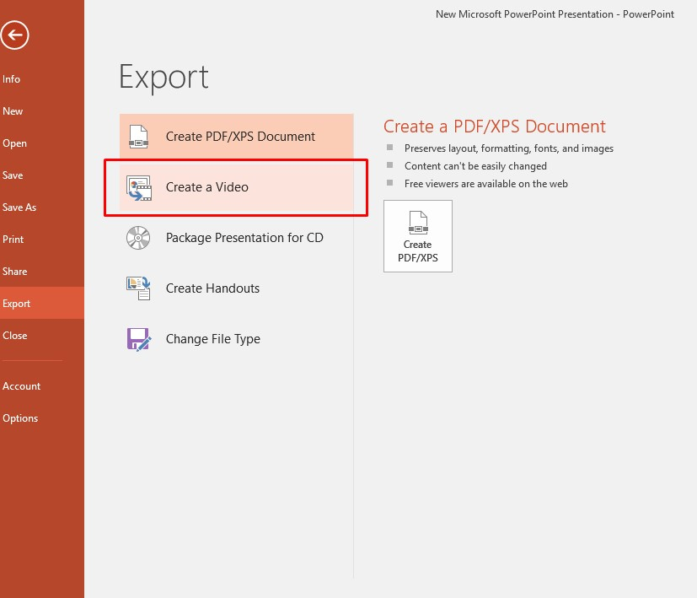

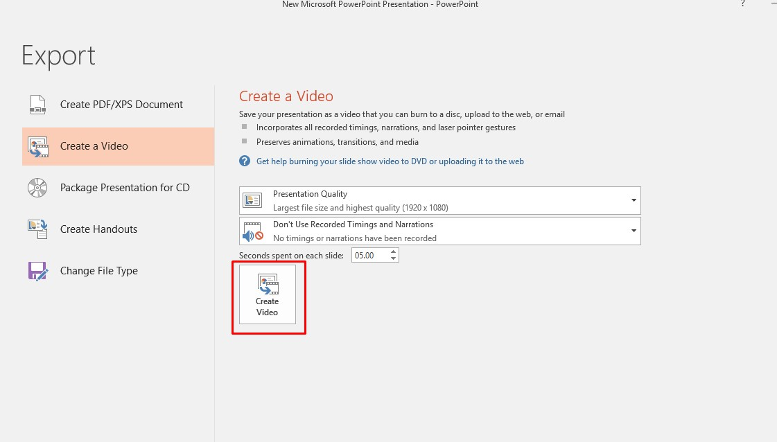 Click Create Video

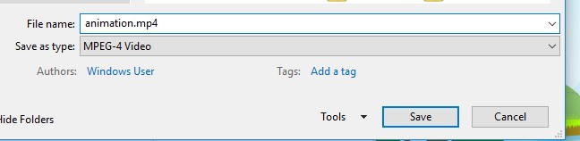name this file to animation and save as MPEG-4 Video format.

Check the desktop. Your desired animation file is there.

